………………… ……………………………
Date Signature of the person running the Diploma Workshop

Appendix no. 2 to Regulation no. 56 – 2020/2021 of the Rector of Kozminski University of 1 July 2021



Mikołaj Paweł Sapek
Student ID no. 47588

The Impact of Third-Force Candidates on Voter Turnout in the 2020 and 2015 Polish Presidential Election and a Forecast for 2025

Final project developed within the framework of the Diploma workshop
Course instructor: Monika Sońta, PhD

Warsaw 2025
Author of the project: Mikołaj Paweł Sapek
Field of study: Bachelor in Management and Artificial Intelligence
Project title: The Impact of Third-Force Candidates on Voter Turnout in the 2020 Polish Presidential Election and a Forecast for 2025

Word count: 4104 (08.06.2025)
Date of submission: dd/mm/rrrr

Statement of authorship I hereby declare that:
- the undermentioned project titled:
The Impact of Third-Force Candidates on Voter Turnout in the 2020 Polish Presidential Election and a Forecast for 2025 submitted at Kozminski University, has been written by me alone, unassisted, and has never served as the basis for any official procedure involving taking steps leading to obtaining a higher education diploma confirming the conferment of an academic degree;
- my project does not violate any copyright within the meaning of the act of 4 February 1994 on copyright and related rights (Journal of Laws of the Republic of Poland of 2020 item 2509) or moral rights protected under the law.
- project was/was not* prepared with the assistance of the automatic text generator ChatGPT. The tool was used to support the formulation of research hypotheses, structure of the thesis, statistical interpretation, and editing in English. The author independently conducted all data analysis, provided original ideas, selected sources, and critically assessed the output generated by the model. The use of ChatGPT served solely as a writing aid, not as a replacement for original academic work.
- text of the uploaded diploma project is identical with the text of the project accepted by the project instructor
*Underline the appropriate

- Contents
II. introduction 2
III. Problem Statement 3
IV. Background: The 2020 and 2015 Polish Presidential Election 4
V. Political Campaigns and Voter Mobilization: A Brief Overview 5
VI. Image Construction by Campaign Teams in the 2020 Presidential Election 7
VII. Data and Methodology 8
VIII. Statistical Analysis of Voter Turnout Changes 9
IX. Regression Results and Interpretation 12
X. Limitations of the Study 18
XI. Proposed Solution: Targeted Strategies to Mitigate Voter Drop-Off 18
XII. Conclusions 19
List of figures/graphs/charts 20
References 21
Appendixes 22
I.1 Rules of using footnotes 25
I.2 Rules of application of the Harvard system 25
I.3 Rules of application of the APA system 26
I.4 Direct quotations 28
I.5 Rules of drawing up a list of references (bibliography) 28

Abstract
This paper examines how third-force candidates influenced voter turnout in the 2020 and 2015 Polish presidential election and considers whether similar demobilization may occur in 2025. It focuses on the rise of alternatives like Szymon Hołownia and Krzysztof Bosak, who appealed to voters disillusioned with mainstream politics, as well as the legacy of Paweł Kukiz, whose 2015 campaign remains Poland’s most notable protest candidacy.
A key issue addressed is the frustration of protest voters, who often disengage after their candidate is eliminated in the first round leading to lower turnout in the runoff and raising concerns about political alienation and democratic legitimacy.
Using official county-level data, the study applies statistical tools, including Welch’s t-tests and linear regression, to test whether second-round turnout rose more slowly in areas with above-average support for Hołownia, Bosak, or Kukiz. The results confirm a significant correlation between strong first-round support for these candidates and lower turnout growth in the second round.
This suggests protest voters are more likely to abstain when their preferred candidate is eliminated. The thesis ends by projecting that similar patterns could emerge in 2025, with figures like Mentzen or Hołownia attracting protest votes and risking second-round demobilization. It offers insights into protest voting and recommends strategies for better voter engagement.

introduction
Understanding what drives voter turnout is key to upholding democratic legitimacy. Among these factors, “third-force” or “protest” candidates those outside the mainstream party system have drawn increasing attention for attracting disillusioned voters and boosting first-round participation. However, their elimination before the runoff raises concerns about reduced engagement in the second round. This thesis focuses on the 2020 Polish presidential election, where Szymon Hołownia and Krzysztof Bosak played major third-force roles. Though neither advanced, their supporters formed a politically distinct and sizeable group. The study also references the 2015 election, emphasizing Paweł Kukiz’s protest campaign, which introduced digital mobilization tactics and achieved the highest protest vote in modern Polish history.
The core research question is whether counties with strong support for these candidates experienced smaller increases in second-round turnout than other regions.
The study has two main aims:
(1) to evaluate how first-round support for third-force candidates influenced second-round turnout in 2020, and 2015
(2) to forecast whether similar demobilization may occur in 2025 in areas likely to back candidates such as Mentzen or Hołownia.
Relying on county-level election data, the study uses descriptive statistics, Welch’s t-tests, and linear regression to analyze turnout differences between counties with high and low third-force support. It contributes to the literature on protest voting and offers practical recommendations for political campaigns and election officials. More broadly, the thesis reflects on rising polarization and the decline of traditional party loyalties in favor of issue-based or anti-establishment sentiment. As Neyra (2020) notes, protest voters often express “deep social alienation in a polarized system,” making their behavior vital to understanding democratic stability.

Problem Statement
A major challenge in modern democracies is sustaining voter engagement across multiple election stages. In Poland’s 2020 presidential election, many voters especially the young and politically disillusioned supported third-force candidates like Szymon Hołownia and Krzysztof Bosak in the first round. Their support often reflected protest rather than ideological alignment. When these candidates failed to advance, many of their voters abstained from the runoff entirely. This post-elimination “voter demobilization” is a recurring issue in two-round systems. It reflects deep dissatisfaction among citizens who feel the final candidates don’t represent their values, leading to apathy or deliberate abstention. Such disengagement weakens electoral legitimacy and undermines broad democratic participation. Data from 2020 supports this concern. In counties with above-average support for Hołownia or Bosak, second-round turnout increases were statistically significantly lower. Welch’s t-tests and regression analysis confirm a pattern: the higher the initial protest vote, the smaller the turnout gain in the runoff. This effect is even more pronounced when examining data from the 2015 election, where protest voting and subsequent demobilization showed stronger regional disparities.
If unaddressed, this trend may repeat in 2025 with candidates like Mentzen or a returning Hołownia. Without targeted engagement, alienated voters could again withdraw at a crucial stage undermining legitimacy and deepening polarization.

Background: The 2020 and 2015 Polish Presidential Election
A key context for the 2020 Polish presidential election was widespread fatigue with Civic Platform’s (PO) eight-year rule, which left many voters disillusioned with mainstream politics. In this climate, Paweł Kukiz rose as the most successful protest candidate in 2015, earning 20% in the first round. His anti-establishment appeal strongly resonated with voters rejecting the PO–PiS duopoly.
The 2020 election, among the most polarized since 1989, was delayed from May 10 to June 28 (first round) and July 12 (runoff) due to the COVID-19 pandemic, intensifying political tensions (Błaszczyński, 2020; IFES, 2020). Eleven candidates competed. The main contenders were President Andrzej Duda (PiS), who received 43.5%, and Rafał Trzaskowski (PO), who gained 30.5%, triggering a runoff. However, third-force candidates Hołownia (13.9%) and Bosak (6.8%) together captured over 20% of the vote.
Hołownia, a centrist journalist, appealed to moderate, pro-European voters seeking alternatives to party politics. Bosak, from the far-right Confederation, attracted nationalist and libertarian youth. Despite ideological differences, both were seen as anti-establishment and drew strong regional support (Madej, 2020).
Turnout rose from 64.5% in the first round to 68.2% in the second. While this national increase seemed modest, regions with strong Hołownia and Bosak support showed notably smaller gains—suggesting that many of their voters felt unrepresented and abstained (Madej, 2020).
Duda narrowly won with 51.0% over Trzaskowski’s 49.0%. The tight margin highlighted how protest voter disengagement may have tipped the balance.
In my view, without the extreme polarization and strategic postponement by both PiS and PO, the result might have differed. PO initially backed Małgorzata Kidawa-Błońska, whose support had collapsed. The delay allowed PO to replace her with Trzaskowski. Had the original vote gone ahead, PO may have withdrawn support and backed Hołownia, the strongest alternative. In that case, Hołownia could plausibly have beaten Duda in the runoff.
This chapter sets the stage for the next sections, which will analyze turnout shifts and assess how third-force support predicts voter demobilization.
Figure 1. Voter migration of Hołownia and Bosak supporters between rounds 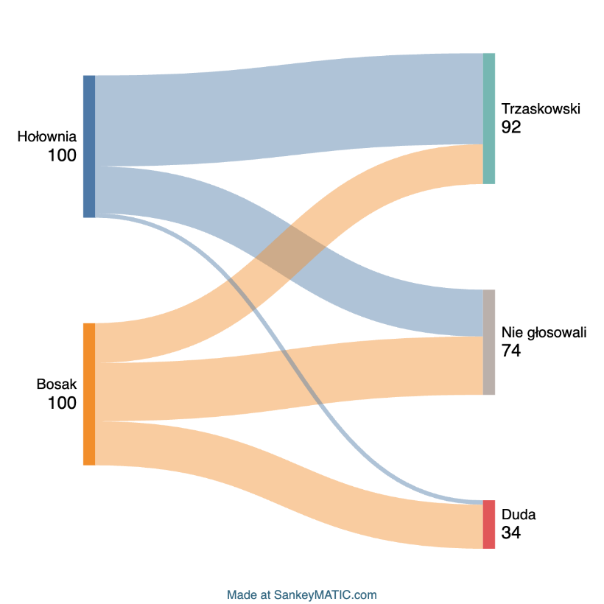

Political Campaigns and Voter Mobilization: A Brief Overview
The 2020 election marked the second in a row after 2015 where non-mainstream candidates emphasized anti-establishment messages. They criticized the longstanding dominance of Civic Platform (PO) and Law and Justice (PiS), appealing to voters fatigued by political polarization and repeated power shifts (Neyra, 2020). This messaging helped third-force candidates stand out from their mainstream opponents.
In 2015, Paweł Kukiz set a precedent by running Poland’s first major social media–driven campaign. He used platforms like Facebook, YouTube, and Twitter to reach younger, digitally engaged voters and bypass traditional media. His grassroots digital strategy mobilized protest voters and paved the way for similar efforts by Hołownia and Bosak. This shift highlighted the growing role of digital campaigning in Polish elections.
The 2020 race featured contrasting outreach strategies among top candidates Duda, Trzaskowski, Hołownia, and Bosak which reflected their platforms and helped them connect with distinct voter segments (Madej, 2020).
Duda, as incumbent, relied on public media, local networks, and traditional rallies. He framed his message around sovereignty and conservative values, targeting rural and older voters.
Trzaskowski, a centrist and modernizer, embraced online campaigning amid COVID-19 restrictions. His campaign appealed to urban, educated, pro-European voters with polished media content. However, his late entry replacing Kidawa-Błońska required rapid momentum-building. Hołownia ran an independent, grassroots campaign powered by volunteers, crowdfunding, and platforms like Facebook Live and YouTube. He emphasized civic values, trust, and independence from party elites, attracting moderate, disillusioned voters.
Bosak targeted nationalist, libertarian, and young voters using social media like TikTok and Twitter. His concise ideological content promoted economic freedom and national identity, positioning him firmly against the establishment. These diverse mobilization strategies helped drive high turnout despite the pandemic (Błaszczyński, 2020). Yet they also revealed the electorate’s fragmentation. While third-force campaigns energized first-round participation, their elimination may have fueled later disengagement among their supporters.
Figure 2 Choropleth map: Counties with above-average support for Bosak, Hołownia or both
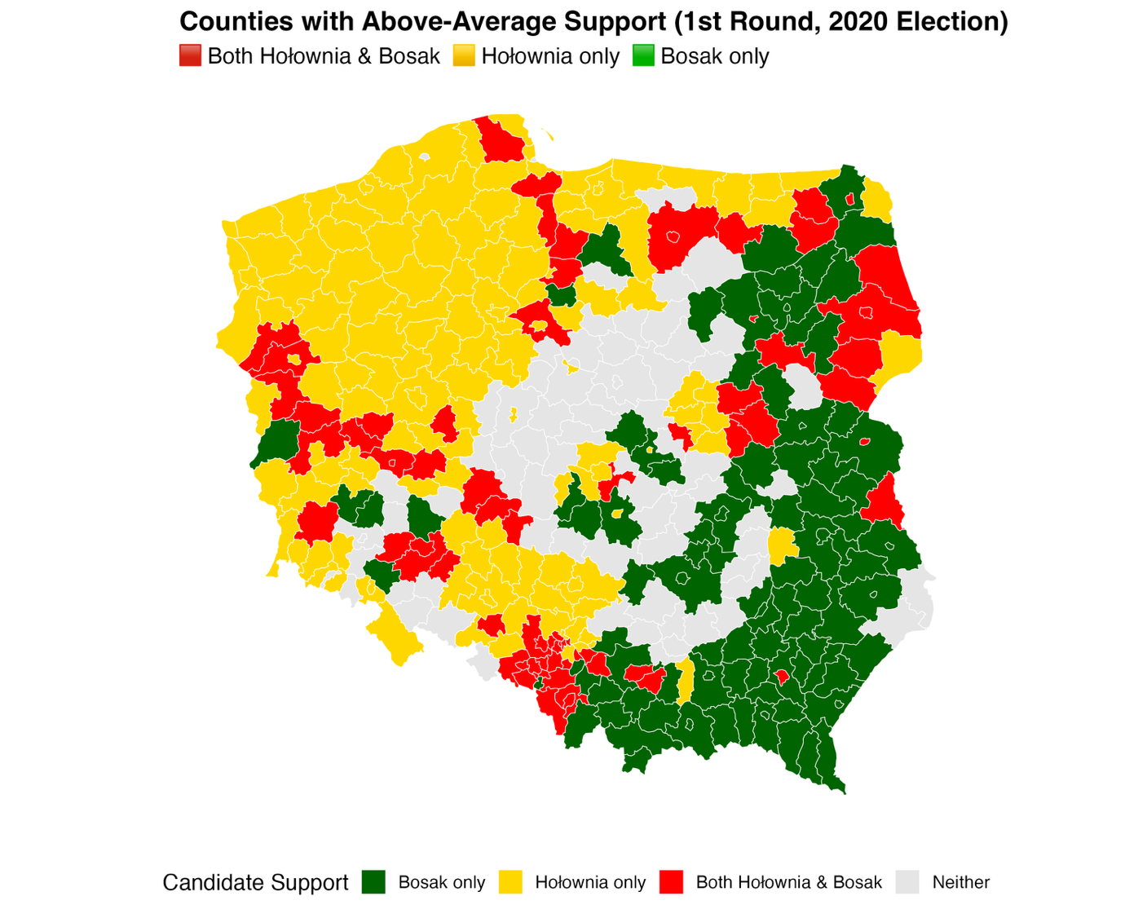

Image Construction by Campaign Teams in the 2020 Presidential Election
In the 2020 Polish presidential election, Szymon Hołownia and Krzysztof Bosak stood out as major third-force candidates. Despite differing ideologies Hołownia as a civic centrist, Bosak as a nationalist-libertarian both challenged the PiS–PO duopoly. Their campaigns targeted disillusioned voters and used depolarizing rhetoric shaped by distinct political cultures.
Paweł Kukiz The “President in Glany”
Kukiz's 2015 campaign inspired later third-force efforts. Through social media and a rebellious image, he bypassed traditional media to reach younger voters and protest sympathizers. His success (20% in the first round) showed the power of digital outreach and grassroots mobilization, setting the stage for candidates like Hołownia and Bosak.
Szymon Hołownia The Civic Unifier
Hołownia’s campaign, led by strategist Michał Kobosko, crafted an image of a modern, nonpartisan leader. His team emphasized trust, emotional tone, and citizen engagement. Visuals portrayed him in relaxed, humanized settings, reinforcing his slogan “You are not alone.” Rather than attack opponents, Hołownia promoted dialogue, democratic renewal, and civic responsibility, aiming to unify voters through empathy and modernity.
Krzysztof Bosak The Intellectual Dissenter
Bosak appealed to nationalist and libertarian youth. His campaign, shaped by strategist Tomasz Grabarczyk and advisor Artur Dziambor, emphasized ideological consistency and disciplined messaging. Bosak’s formal style and academic tone projected seriousness, while his slogan “No to the establishment” positioned him against both PiS and PO. His rhetoric, though confrontational, included depolarizing elements, presenting him as a principled alternative to partisan politics.
Shared Strategy, Different Style
Though Hołownia and Bosak targeted different demographics, both rejected mainstream politics and built distinct personal brands. Hołownia stressed civic unity and emotional connection, while Bosak relied on ideological sharpness. Each campaign maintained strict control over public image and authenticity.
The 2020 election showed that non-mainstream candidates can build political capital through strategic branding, even without party structures. With small, skilled teams, both Hołownia and Bosak crafted compelling narratives outside the PiS–PO binary. As Neyra (2020) notes, depolarization is increasingly used across Europe as a rhetorical strategy to appeal to voters weary of entrenched political conflict.

Data and Methodology
This chapter outlines the data, variables, and statistical methods used to examine the relationship between support for third-force candidates and changes in voter turnout during Poland’s 2020 presidential election. The analysis is conducted at the county level, using official results to test whether higher first-round support for Szymon Hołownia or Krzysztof Bosak correlates with smaller increases in turnout in the second round (Madej, 2020a).
Data Sources:
The study uses official data from the Polish National Electoral Commission, covering all 380 counties (powiats). Variables include:
• Eligible voters
• Valid votes
• Turnout rate
• Candidate vote counts
• County and voivodeship names
Geolocation codes were also included to enable spatial analysis through thematic maps, helping visualize regional differences in turnout and political behavior.
Data Processing:
Election data were imported into RStudio and cleaned. New variables were created to measure turnout change between rounds and to calculate Hołownia and Bosak’s first-round vote shares. Binary flags identified counties with above-average support, based on national means: 13.45% for Hołownia and 6.78% for Bosak (Madej, 2020b). Additionally, data from the 2015 presidential election focusing on Paweł Kukiz’s protest vote were incorporated to enrich the analysis of protest voting dynamics.
Statistical Methods:
Welch’s two-sample t-tests compared turnout increases in counties with above- and below-average support for each candidate. Linear regression was also used to explore whether a continuous relationship exists between first-round support and turnout change. The dependent variable was turnout difference; the independent variable was candidate vote share. Coefficients, p-values, and R² were analyzed to assess the strength and significance of results (Madej, 2020a).
This framework supports the main research hypothesis and forms the foundation for the predictive model discussed in later chapters.

Statistical Analysis of Voter Turnout Changes
While the focus was on turnout shifts, it’s worth briefly contextualizing Szymon Hołownia’s third-place performance. Early 2020 polling, prior to the postponed May election, showed Hołownia above 20%, benefiting from his centrist appeal in a polarized climate. However, the delay and Civic Platform’s switch from Kidawa-Błońska to Trzaskowski squeezed his space in the center (Błaszczyński, 2020).
Ultimately, Hołownia earned 13.87% a typical third-place finish, but still representing a sizable, distinct voting bloc. Many of these voters later disengaged from the runoff.
This chapter analyzed whether counties with above-average support for Hołownia or Bosak showed different patterns in turnout change between election rounds.
Nationally, turnout rose by 4.11 percentage points (from 64.51% to 68.62%). Disaggregated county-level data revealed clear differences (Madej, 2020b):
- Hołownia: 198 counties had above-average support (>13.45%). In those, the average turnout increase was 3.87 pp, compared to 4.40 pp elsewhere a 0.53 pp gap, statistically significant.
- Bosak: In counties with support above 6.78%, the average turnout rise was 4.03 pp vs. 4.68 pp elsewhere a 0.65 pp difference, also significant.
These patterns confirm that voters for third-force candidates were more likely to abstain when their candidate was eliminated. Their engagement was conditional and protest-driven (Neyra, 2020). To determine whether this was real demobilization and not just statistical noise, the study also considered behavioral data. IPSOS exit polls after the second round showed that 33% of Hołownia’s and 41% of Bosak’s voters abstained (IPSOS, 2020). Only 3% of Hołownia’s voters backed Duda; 64% supported Trzaskowski. Bosak’s supporters were more split, but many stayed home. This aligns with the county-level results and underscores that these voters rejected the binary runoff.
Additionally, the study examined the legacy of Paweł Kukiz’s 2015 campaign. Kukiz mobilized roughly 20% of voters in the first round mainly protest voters disillusioned with mainstream parties. Counties where Kukiz had above-average 2015 support showed even greater demobilization in 2020: turnout increased by just 5.74 pp, compared to 7.07 pp in other counties. This means that turnout increased by 1.33 percentage points less in counties with strong historical support for Kukiz. These findings reinforce the thesis: protest voters are conditionally engaged and likely to disengage when not represented, raising concerns about democratic legitimacy and participation in runoffs.
Figure 3. Bar chart: Average turnout change by candidate support level
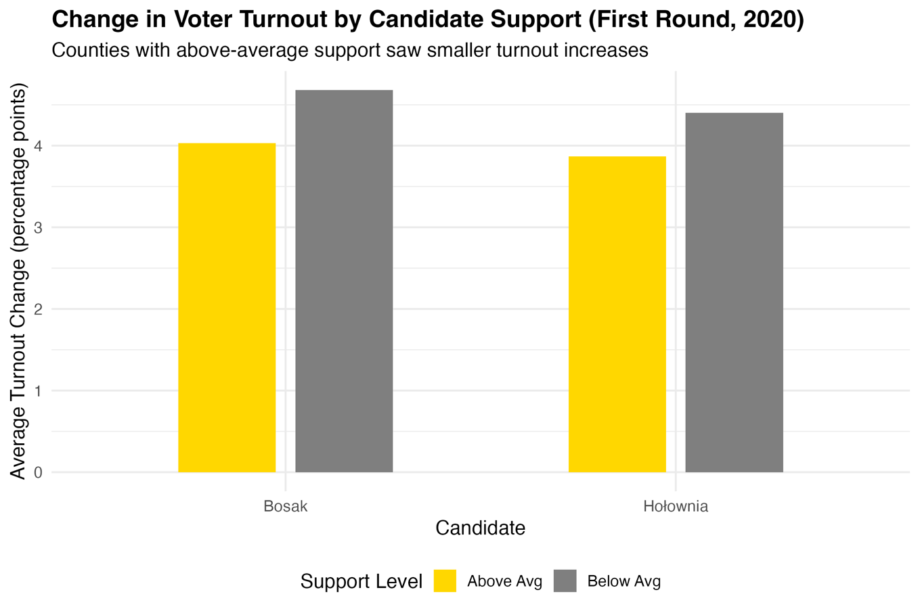
Figure 4. Change in voter turnout Map
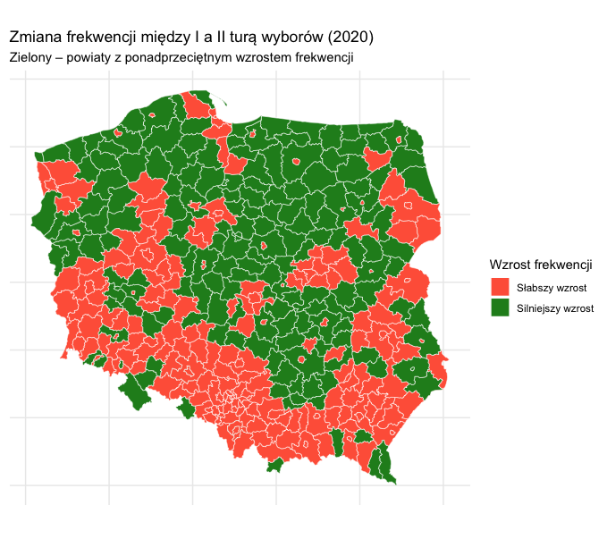

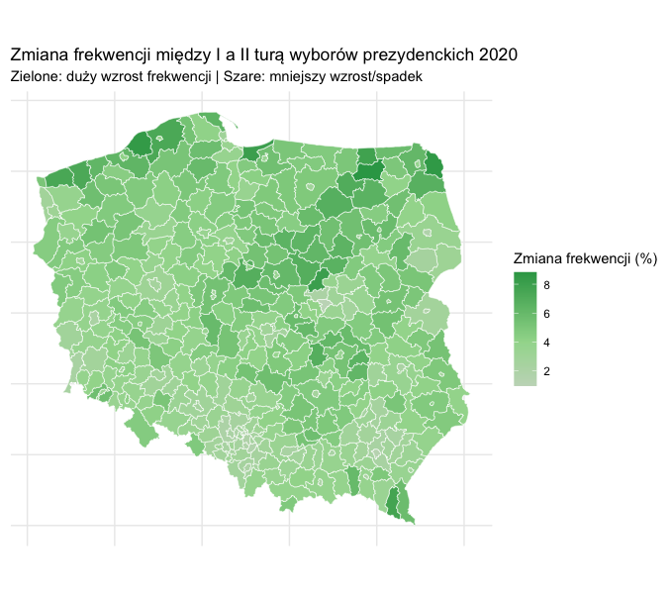
Figure 5. Change in voter turnout Map

Regression Results and Interpretation
To deepen the findings from the previous section, this chapter examines whether there is a continuous statistical relationship between support for third-force candidates and the magnitude of voter turnout change between election rounds. Specifically, linear regression analysis was used to estimate how changes in voter engagement relate to first-round support for Szymon Hołownia and Krzysztof Bosak across Poland’s 380 counties (Madej, 2020a). In each model, the dependent variable was the change in turnout between the first and second rounds, while the independent variable was the candidate’s first-round vote share (expressed in percentages). Two separate models were constructed.
Regression Model – Szymon Hołownia
- Intercept: 5.15
- Slope coefficient: –0.076
- p-value: < 0.0001
- R²: 0.042
This result indicates that counties where Hołownia received more votes in the first round generally saw smaller increases in turnout between rounds. On average, each percentage point increase in his vote share corresponds with a 0.076-point smaller increase in turnout. Although the R² suggests a relatively low proportion of explained variance, the statistical significance is strong (Madej, 2020a).
Regression Model – Krzysztof Bosak
- Intercept: 6.73
- Slope coefficient: –0.388
- p-value: < 0.0001
- R²: 0.119
This model shows an even stronger negative relationship: higher support for Bosak is associated with a sharper decline in turnout growth. Again, although the R² is low, the consistency and significance of the relationship support the interpretation that Bosak’s voters were especially likely to disengage.
Regression Model – Paweł Kukiz
In addition to the models for Hołownia and Bosak, a similar linear regression analysis was conducted to examine the relationship between Paweł Kukiz’s first-round vote share (from the 2015 presidential election) and subsequent changes in voter turnout. This was to explore whether the protest electorate mobilized by Kukiz exhibited comparable demobilization patterns in runoff elections.
- Intercept: 6.20
- Slope coefficient: –0.090
- p-value: < 0.0001
- R²: 0.055
This model indicates a statistically significant negative relationship between Kukiz’s vote share and the increase in turnout between election rounds. Specifically, for each percentage point increase in Kukiz’s first-round support, the turnout growth decreased on average by approximately 0.09 percentage points. Although the R² value remains low—indicating that much of the variation in turnout changes is explained by other factors—the effect is statistically robust. The slightly stronger negative slope compared to Hołownia (–0.076) and Bosak (–0.388) suggests that Kukiz’s electorate may be even more prone to disengagement when their preferred candidate is not present in subsequent rounds. This aligns with previous findings that protest voters tend to conditionally participate, withdrawing support if their candidate is eliminated.
Interpretation
The low R² values (below 0.1) suggest that other factors beyond candidate support explain most of the variation in turnout changes. However, in large datasets such as this one, even weak correlations can be meaningful when statistically robust. Here, the direction and significance of the coefficients confirm what the group comparisons already hinted at: there is a systematic, measurable link between third-force support and decreased second-round participation (Madej, 2020a). These patterns suggest that the demobilization of third-force voters is not merely anecdotal or confined to isolated regions. Instead, it reflects a broader behavioral trend among politically disengaged or protest-driven electorates who are less likely to accept binary electoral choices (Neyra, 2020). These consistent statistical patterns reveal more than just numerical trends they expose a structural challenge within Poland’s democratic system. A significant portion of the electorate, particularly those who support third-force candidates, often chooses not to participate in the second round. While this choice is frequently portrayed as apathy, it is essential to recognize that abstaining is also a political act (IPSOS, 2020; Neyra, 2020). It is often a conscious rejection of the limited options presented in a binary runoff, especially within a political environment dominated by two long-standing parties. However, the growing scale of such demobilization cannot be ignored. When voter withdrawal becomes a norm in certain regions or among specific ideological groups, it weakens the representative legitimacy of elected officials and contributes to a cycle of disillusionment and disengagem.

Figure 6. Linear Regression Bosak
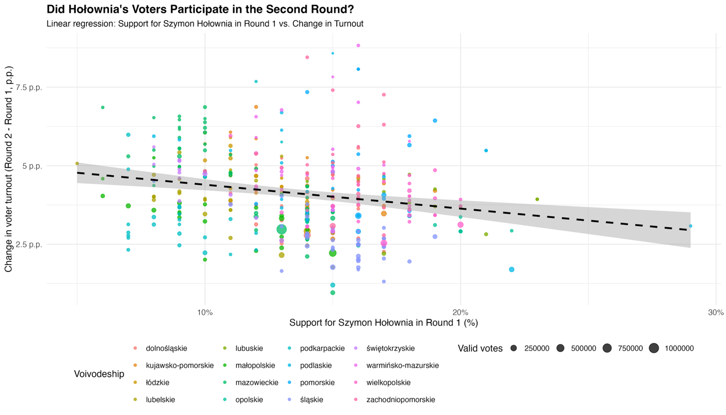

Figure 7. Linear Regression Bosak
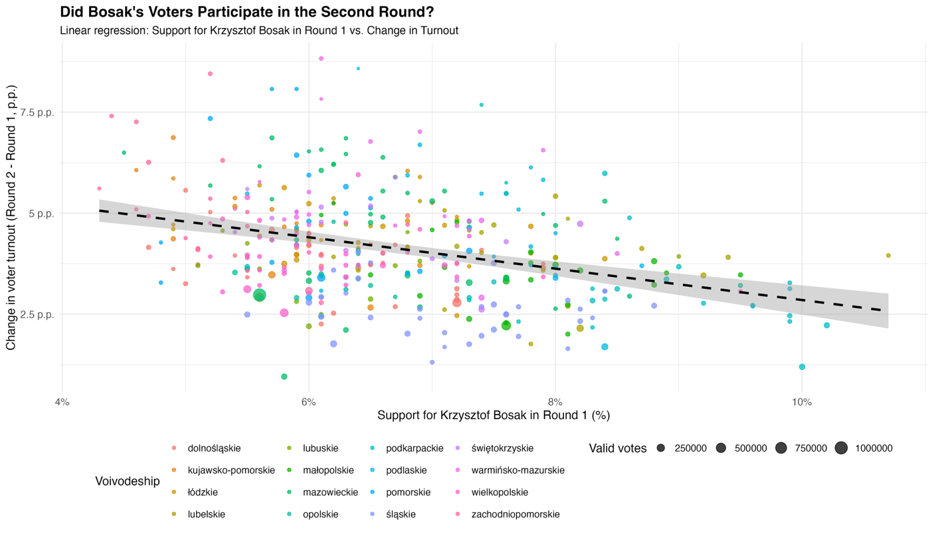

Predictive Scenario for the 2025 Presidential Election
Building on 2020 election patterns, this chapter forecasts voter behavior for 2025, focusing on the potential demobilization of third-force voters. While 2020 saw significant abstention from Hołownia’s (33%) and Bosak’s (41%) supporters in the runoff (IPSOS, 2020), similar outcomes are not guaranteed in 2025 there are signs the trend may reverse. Previous analysis showed that counties with above-average first-round support for Hołownia and Bosak experienced smaller second-round turnout increases. This was backed by t-tests, regression results, and IPSOS behavioral data. In 2025, Sławomir Mentzen and Hołownia are again expected to draw protest voters. Mentzen’s appeal echoes Bosak’s libertarian youth base, while Hołownia continues to attract moderates disillusioned with PiS–PO politics. However, past experience may motivate these voters to stay engaged in the second round, having learned that abstention weakens their political leverage (Madej, 2020a). Higher overall turnout is also anticipated, driven by more engaged younger voters, digital mobilization, and greater awareness of political consequences. Rather than apathy, 2025 may reflect a stronger civic impulse especially among past protest voters (Neyra, 2020).
Still, structural barriers remain. Voter fatigue with limited runoff options and the dominance of two parties continues to alienate many. Importantly, this thesis also treats second-round abstention as a valid form of protest a deliberate rejection of insufficient political choice.
Based on these insights, several counties have been identified as likely sites of either renewed turnout or continued demobilization. These include areas where Hołownia or Bosak performed strongly in 2020 but second-round growth was modest:
- Pruszkowski
- Rzeszów
- Siemianowice Śląskie
- Świętochłowice
- Białystok
- Bieruńsko-lędziński
- Gliwicki
- Rzeszowski
- Leżajski
- Oświęcimski
In places like Rzeszów and Białystok, high first-round turnout may reflect saturation rather than apathy. Larger urban areas often show early mobilization due to better information access and civic engagement, limiting second-round gains. While many call the 2025 election “the most important in decades,” this thesis challenges that view. Such framing is often strategic, used by political elites to stir urgency without real political transformation. What matters more is actual voter behavior. If turnout is high, it reflects effective messaging not necessarily greater importance. And if protest voters abstain again, it signals persistent dissatisfaction with limited choices. In this sense, 2025 may not mark a political shift but a reflection of ongoing patterns. Voter behavio not campaign rhetoric will reveal whether anything has truly changed.
Figure 8.Forcasted Counties
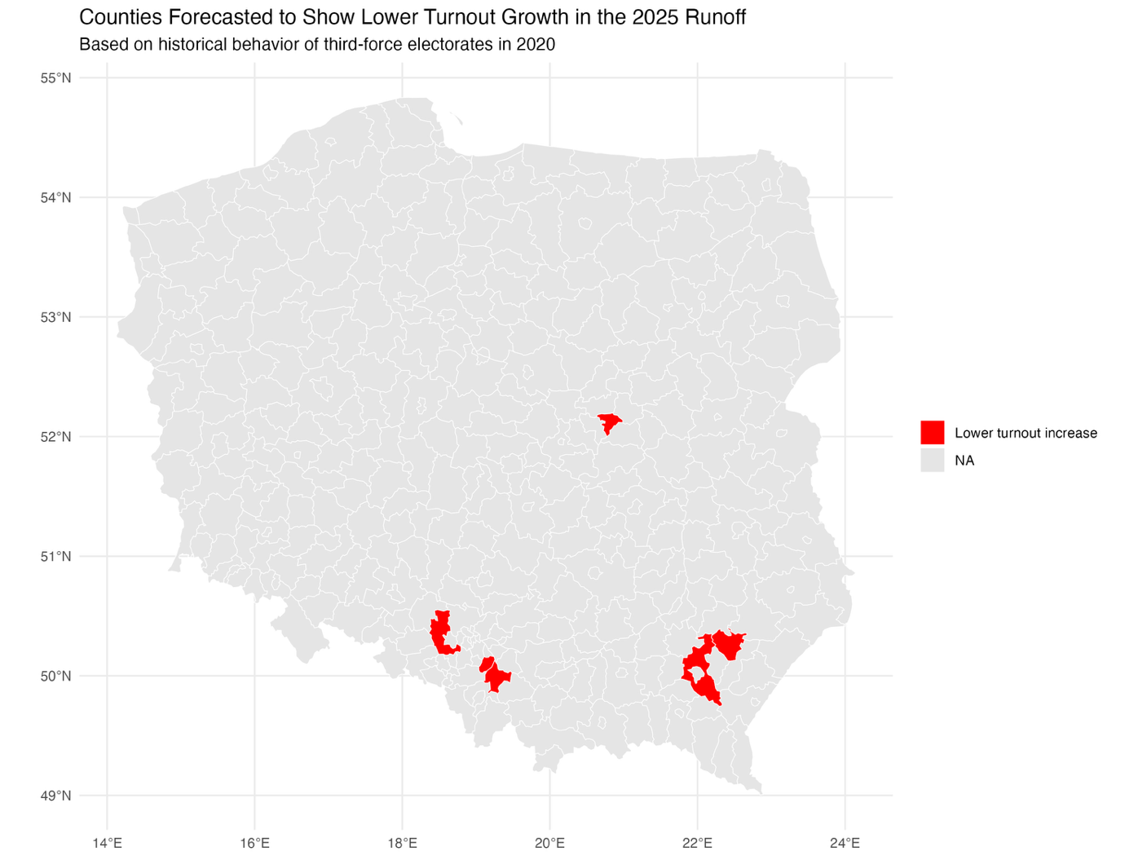

Figure 9. Forcast Turnout
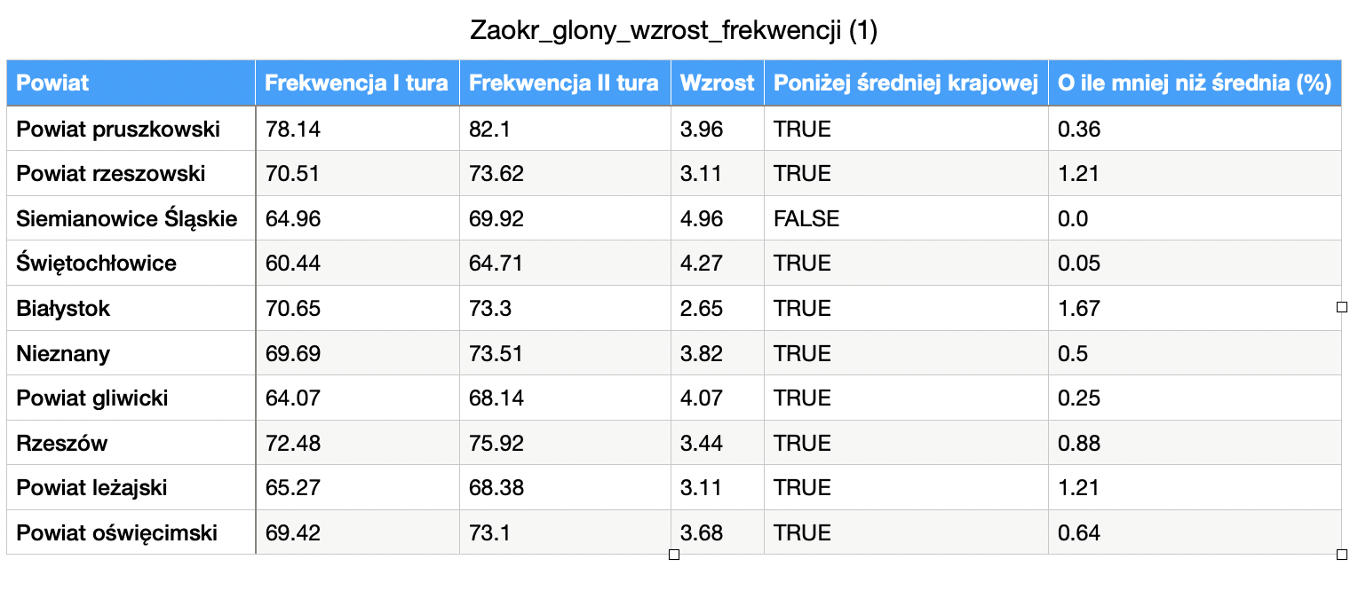

Limitations of the Study
While this study offers valuable insights into voter behavior in Poland’s 2020 presidential election, several limitations must be acknowledged. First, the analysis is based on county-level aggregated data, limiting conclusions about individual motivations and behaviors (Madej, 2020b). To provide broader context, data from the 2015 election were also examined to trace the evolution of protest voting. Second, the study does not account for external factors such as regional campaign activity, weather on election days, or local logistical issues, which could have influenced turnout shifts. Third, although regression analyses showed significant results, the low R² values suggest much of the variation in turnout change is unexplained by candidate support alone. Additionally, while IPSOS (2020) exit polls are heavily referenced, they remain estimates and cannot substitute for official turnout records. This highlights the challenge of fully capturing voter behavior at the individual level. The 2025 forecast assumes political continuity, which may not hold if major shifts occur in party alliances, candidate profiles, or public sentiment (Neyra, 2020). Despite these limitations, the study lays a strong foundation for future research on protest voting and political disengagement. Further studies could benefit from individual-level data, regional context analysis, and deeper exploration of voter mobilization within Poland’s increasingly fragmented political landscape.

Proposed Solution: Targeted Strategies to Mitigate Voter Drop-Off
Tackling voter demobilization among protest voters requires more than campaign strategies it calls for systemic reforms to enhance engagement and representation. Two key recommendations arise from this study. First, lowering the electoral threshold for entering the Polish Sejm from 5% to 3% could broaden political inclusion. This would enable more small parties often aligned with protest or niche ideologies to gain parliamentary presence. Greater representation could reduce alienation among voters who feel excluded by the PiS–PO duopoly, softening polarization and encouraging second-round participation. Second, implementing remote voting options, such as secure digital voting via the mObywatel app, would reduce participation barriers. Although overall accessibility is high, groups like youth abroad, internal migrants, and people with disabilities still face logistical hurdles. Verified digital voting could offer greater flexibility and foster continued engagement, particularly in runoffs. Together, these reforms—greater institutional inclusivity and technological accessibility—propose a long-term solution to demobilization. By giving protest voters both representation and practical voting options, they can help improve democratic participation and legitimacy.

Conclusions
This thesis explored how third-force candidates influenced voter turnout in Poland’s 2020 presidential election and assessed whether similar trends could emerge in 2025. Using county-level data, t-tests, and linear regression, it found that counties with strong first-round support for Hołownia and Bosak saw significantly smaller second-round turnout increases. Exit poll data showing that 33% of Hołownia’s and 41% of Bosak’s supporters abstained reinforce this pattern of disengagement among protest voters.
The analysis also included data from the 2015 election, focusing on Paweł Kukiz, whose supporters similarly showed reduced second-round turnout. This consistent behavior reflects a broader trend: protest voters often disengage when faced with a binary runoff between PiS and PO, not out of apathy, but as a conscious rejection of mainstream choices.
Looking ahead to 2025, the study offers a cautious forecast. Candidates like Mentzen and Hołownia may again rally protest voters, but their supporters could behave differently. Greater political awareness, digital mobilization, and belief in electoral impact may increase second-round participation if systemic frustrations are genuinely addressed rather than masked by rhetoric.
The thesis also challenges the notion that 2025 is uniquely critical. Every democratic election is significant, and framing one as “the most important” often serves political ends rather than reflecting deeper truth. Poland does face political and institutional challenges, but national discourse is frequently shaped by historical anxiety and rhetorical overstatement. This tendency risks amplifying instability and undermining confidence in democratic continuity.
Rather than a dramatic turning point, the 2025 election may act as a mirror revealing both the persistent strains in Polish democracy and its enduring civic strength. Differentiating real structural problems from culturally driven anxieties is key to understanding what needs reform and what already works.

List of figures/graphs/charts
Figure 1. Voter migration of Hołownia and Bosak supporters between rounds (Sankey diagram)
Source: IPSOS exit poll visualization.
Page: 6
Figure 2. Choropleth map: Counties with above-average support for Bosak, Hołownia or both
Classification map showing split support across counties.
Source: Author’s classification based on PKW data.
Page: 8
Figure 3. Bar chart: Average turnout change by candidate support level
Source: Author’s own calculation, county-level data.
Page: 12
Figure 4. Change in voter turnout map (binary: stronger vs. weaker growth)
Source: Państwowa Komisja Wyborcza.
Page: 12
Figure 5. Change in voter turnout map (gradient, % increase)
Source: Państwowa Komisja Wyborcza.
Page: 13
Figure 6. Linear regression – Bosak’s support vs. turnout change
Source: Author’s calculation, n = 380.
Page: 15
Figure 7. Linear regression – Hołownia’s support vs. turnout change
Source: Author’s calculation, n = 380.
Page: 14
Figure 8. Forecast map – counties likely to show low turnout growth in 2025
Based on third-force support and past turnout data.
*Source: Author’s forecast based on PKW data.
Page: 17
Figure 9. Forecast table – projected turnout change by county
Source: Author’s own calculation.
Page: 17

References
Błaszczyński, K. (2020) In the Shadow of Plagues: 2020 Presidential Elections in Poland. [online] ResearchGate. Available at: https://www.researchgate.net/publication/343413365 [Accessed 18 May 2025].
International Foundation for Electoral Systems (2020) Poland: Presidential Election 2020 Scene-Setter. [online] IFES. Available at: https://www.ifes.org [Accessed 18 May 2025].
IPSOS (2020) Exit Poll Data from Polish Presidential Election 2020. [online] Cited in major media outlets including TVN24, Polityka.pl. [Accessed 18 May 2025].
Madej, M. (2020a) Economic Parameters vs Voting Behaviour in the Polish Presidential Election in 2020. [online] ResearchGate. Available at: https://www.researchgate.net/publication/343566962 [Accessed 18 May 2025].
Madej, M. (2020b) Voter Turnout and Results of the Presidential Elections in Poland 2020. [online] ResearchGate. Available at: https://www.researchgate.net/publication/343568421 [Accessed 18 May 2025].
Neyra, A.-S. (2020) “Polish People Are Starting to Hate Polish People”—Uncovering Emergent Patterns of Electoral Hostility in Post-Communist Europe. [online] Stanford Cyber Policy Center. Available at: https://cyber.fsi.stanford.edu/publication/electoral-hostility-poland [Accessed 18 May 2025].
Time Magazine (2020) What the U.S. Can Learn From How Other Countries Voted During the Pandemic. [online] Time. Available at: https://time.com/5901611/us-election-pandemic-lessons/ [Accessed 18 May 2025].

Appendixes

Appendix no. 2a to the Regulation no. 56 – 2020/2021 of the Rector of Kozminski University of 1 July 2021

DIPLOMA PROJECT
in the form of a scientific article
-RULES

1. After obtaining the permission from the diploma project’s instructor, a student may prepare the diploma project in the form of a scientific article (10-15 pages). The page limit does not include lists and appendixes, as well as research tools such as questionnaires. 2. The scientific article shall be a synthetic depiction of the scientific problem.
- The scientific article shall meet the requirements set by the project instructor for academic journals, proper to the relevant scientific discipline.
- The scientific article shall be prepared using research methods proper to the relevant scientific discipline, including research techniques and tools. It should also include a description of the scientific problem, justification of the meaning of the described problem, purpose/purposes of the work, problem/scientific problem and/or scientific thesis/theses/hypothesis/hypotheses, as well as research conclusions.
- The diploma project in the form of a scientific article includes: 1) title page.
- statement of the student’s authorship informing that the student has written their diploma project unassisted.
- table of content;
- abstract with the most important elements of the project according to the following structure: justification of the chosen topic and purpose of the project, used research methods and techniques, results, conclusions and recommendations.
- introduction including the research problem, justification of the meaning and up to date of the research problem, purposes of the project, research question/questions and/or scientific hypothesis/hypotheses, the meaning of the topic from the perspective of science and economic/social practice.
- literature review including subject literature referring to the project’s content.
- description of the used research methods, tools and techniques.
- presentation of the most important research results.
- discussion with reference to existing research results within the selected topic, as well as the project’s author's own conclusions compared to these results;
- general, final conclusions presenting the summary of the research results, including main conclusions of methodological and empirical characteristics.
- literature with the list of the used bibliography, netography and other sources.
- list of tables, figures and charts.
- appendixes (e.g. research tools).
6. The scientific article shall meet the following technical requirements:
- A4 format;
- Times New Roman 12-point font.
- 1,5 leading (interline spacing);
- margins: left and right – 2,5 cm.
- project page count (without tables, appendixes and research tools) from 10 to 15 pages.
- page numbering starting from the table of contents.
- The reviewer of the diploma project shall be an academic teacher, holding a research and teaching or research position and having significant academic achievements in the relevant discipline.
- The review of the scientific article comprises of the assessment of the criteria (proper to a relevant discipline and selected by the project instructor) that need to be met by scientific journals. In particular it shall meet the following criteria: assessment of the title, originality and/or up to date of the described problem, assessment of the set research assumptions of the article, including: the research purpose, research methods, research verification, correctness and originality of the conclusions, selection and usage of the literature; evaluation of the quality of the conducted research (especially reliability, and respect to ethical rules and intellectual property rights), formal properness of the text: the article’s structure, language of the text, table/figures construction, citations, sources used. 9. Taking the final examination and graduating is not conditioned to the article’s publication.

Appendix no. 3 to Regulation no. 56 – 2020/2021 of the Rector of Kozminski University of 1 July 2021

I.1 Rules of using footnotes

- for non-serial books:
  - P. Sztompka (2007), Zaufanie. Fundament społeczeństwa, Kraków: Wydawnictwo Znak, p. 64.
  - V. Randall (1988), Political Parties in the Third World, London: Sage, p. 87.

- for chapters in monographs:
  - D. Latusek (2008), Zadania liderów w stymulowaniu kreatywności, in: D. Jemielniak, A. Koźmiński (eds.), Zarządzanie wiedzą, Warsaw: WAiP, p. 157.
  - S. Borkowska (2006), Motywacja i motywowanie, in: H. Król, A. Ludwiczyński (eds.), Zarządzanie zasobami ludzkimi. Tworzenie kapitału ludzkiego organizacji, Warsaw: WN PWN, p. 27;

- for articles:
  - J. Cope (2005), Toward a Dynamic Learning Perspective of Entrepreneurship, Entrepreneurship: Theory & Practice, vol. 29, no. 4: 378.
  - H. A. Simon (1989), Metodologiczne podstawy ekonomii, Prakseologia, 4 (105): 129–152.
  - B. Nowak (2010), Equal access to the energy infrastructure as a precondition to promote competition in the energy market, Energy Policy, vol. 38, issue 7, pp. 3691-3700.

- for websites:
http://www.parp.gov.pl/index/index/1422 (10.07.2010).

I.2 Rules of application of the Harvard system

The main rule of this system is to provide the initials of the name and surname of the author in the text in brackets (in the case of collective publications — the initials of the name and surname of the publication editor with the annotation “ed.”, in the case of collective works without an editor — the abbreviated title), the year of publication, and the page number, e.g.:
- (P. Nowak, 1999, p. 131)
- (M. J. Stankiewicz, ed., 2013, p. 12)
- (Annual Survey. Main Report, 2002, p. 15)

If there are two authors of a specific publication, both surnames shall be provided and separated by the conjunction “and”, e.g.:
- (M. Kossowska and J. Zgud, 2000, p. 31)

If there are three authors, it is possible to provide the surname of the first one and use the Polish abbreviation “i in.” (“and others”) or the Latin abbreviation “et al.”, e.g.:
- (P. Turner et al., 2007, p. 20)

When making references to several works by the same author, published in the same year, to differentiate them, a small letter “a”, “b” etc. is added, e.g.:
- (J. Andrzejczak, 2013a, p. 2)
- (J. Andrzejczak, 2013b, p. 98)
- (J. Andrzejczak, 2013c, p. 125)

In the above case, it must be remembered that the list of the used literature sources must include relevant annotations next to publication dates, e.g.:
- Maj M. (1999a), Biblioteki, Warsaw: SBP, p. 250.
- Maj M. (1999b), Infobroker, Zagadnienia Informacji Naukowej, issue 14, pp. 13– 29.
- Maj M. (1999c), Kształcenie kadr bibliotecznych, Warsaw: PWE, p. 150.

I.3 Rules of application of the APA system

The rules of application of the APA (American Psychological Association) referencing system Bibliographical notes
The main rule of this referencing style involves providing the surname of the author and the year of publishing of a given publication in parentheses (round brackets). In the case of direct quotations, it is necessary to indicate the page number. All these details need to be separated by commas.
- (Nowak, 1999, p. 23)
In the case of citations spanning over several pages, we indicate the page range with a dash
- (Nowak, 1999, pp. 23-25)
If we cite more than work of a given author, the publishing dates in the reference note need to be given in ascending order:
- (Nowak, 1999, 2001)
If we cite several works by one author but published in the same year, it is necessary to add subsequent letters to the dates. The same system needs to be adopted in the list of references.
- (Nowak, 2001a, 2001b)
If a publication has two authors, both surnames need to be included in parentheses — separated with a comma:
- (Nowak, Kowalski, 2003)
In the case of three to five authors, the first citation should include all surnames, but the following citations may include only the name of the first author, the relevant date, and the “et al.” abbreviation:
- First bibliographical note: (Nowak, Kowalski, Malinowski, Iksiński, 2005)
- Subsequent citations: (Nowak et al., 2005)
If a publication has more than five authors, we need to include the surname the first listed author, the “et al.” abbreviation, and the date.
In the case of an edited multi-author publication, the bibliographical note needs to include the surname of the editor. The list of annotated references will include editorial information.
If the surname of the author appears in the text body, only the year of publishing needs to be included in parentheses:
- “Nowak (1999) believes that…”
- “As suggested by Nowak et al. (2005) …”
- “Nowak and Kowalski (2003) have proven that…”
If we refer to works by two different authors with the same surname, the bibliographical note should include initials of their first names.
- (A. Nowak, 1999)
In the case of an indirect citation, i.e. a reference to a publication the author did not have access to but knows it from another publication, it is necessary to quote the surname of the original (primary) publication, and the bibliographical note should include the surname of the author of the relevant secondary source (i.e. one we have used/cited directly), preceded by “after” with a colon. The list of references should include the secondary source used.
- (after: Nowak, 1999 p. 23)
If we cite an unknown author, the bibliographical note needs to include the title of the publication instead of the surname of the author. If the title of the publication is italicized in the list of references, it needs to be italicized in the citation in the text body as well.
- (Raport finansowy, 1999)

I.4 Direct quotations
Direct quotations — when a cited fragment is longer than 40 words, it needs to take the form of a separate paragraph with indentation, without parentheses. If the cited fragment is shorter than 40 words, it needs to be incorporated into the text of the paragraph (main text body), in parentheses.

I.5 Rules of drawing up a list of references (bibliography)

1) The list of references (bibliography) should be compiled in the form of a list, in alphabetical order according to authors’ names using the following format (without providing page numbers next to traditional publications and without the date of site access) in the case of websites. The sources used should be divided into four groups: articles and books, legal acts, online sources, other. The bibliography needs to include only the literature mentioned in the footnotes.

Examples:

Articles and books (alphabetically)

- Cope, J. (2005). Toward a Dynamic Learning Perspective of Entrepreneurship. Entrepreneurship: Theory & Practice, 29(4), 23-45.
- Jemielniak, D., Koźmiński, A. (eds.). (2008). Zarządzanie wiedzą. WAiP.
- Latusek, D. (2008). Zadania liderów w stymulowaniu kreatywności. in: D. Jemielniak, A. Koźmiński (eds.), Zarządzanie wiedzą (pp. 24-48). WAiP.
- Randall V. (1988). Political Parties in the Third World. Sage.
- Sztompka P. (2007). Zaufanie. Fundament społeczeństwa. Wydawnictwo Znak.

Legal acts (chronologically)

- Act of 10 April 1997 – Energy Law (Journal of Laws of Laws of 2006, no. 89, item 625 as amended).
- Decision 1364/2006/EC of the European Parliament and of the Council of 6 September 2006 laying down guidelines for trans-European energy networks. (OJ EU L 262/8 of 22.09.2006).
- Treaty on the Functioning of the European Union. (OJ EU, C 83/47 of 30.03.2010).

Online sources
1. http://www.parp.gov.pl.

- The graphic elements included in a project (e.g. graphs/charts, figures, photographs) should bear a title and indicate the names of their sources. The numbering of graphs/charts, figures, tables, and photographs should be continuous for each of the mentioned graphic elements. The final part of the project should include a list of each graphic form used in the thesis — including an indication of the number of each such form, the title thereof, and the page on which each such form appears.

- Each appendix should be numbered individually. Appendixes need to be organised in the order in which the author of the project refers to them in the content of the project. Each appendix should come with the name of its source provided thereunder. Appendixes may include specimen forms, copies of survey forms, additional texts, statistical data, photographs, tables, stock exchange quotation charts/graphs, fragments of reports, legal acts, financial statements, and other resources or tools used by the author of the project.

- Before the project is printed, the student needs to make sure that it is free of any technical errors and linguistic mistakes.

Appendix no. 4 to Regulation no. 56 – 2020/2021 of the Rector of Kozminski University of 1 July 2021
PROTOKÓŁ EGZAMINU DYPLOMOWEGO NA STUDIACH PIERWSZEGO STOPNIA/ FIRST-CYCLE (UNDERGRADUATE-LEVEL) STUDIES — FINAL EXAMINATION — FINAL EXAMINATION ASSESSMENT REPORT

z dnia _____20_____r./ of _______20_____ (date)

Pan(i)/Mr/Ms ____________________________
urodzony(a) dnia/born on _____________________ w/in ____________________________ student(ka) Akademii Leona Koźmińskiego/student of Kozminski University, numer albumu/student ID no. kierunek/field of study:
zakres/major: -,
rok rozpoczęcia studiów/year of commencement of studies złożył(a) egzamin dyplomowy w dniu/took the final examination on ______20__ przed Komisją Egzaminacyjną w składzie/before the Examination Board composed of:
Przewodniczący/Head of the Board:
Członek Komisji/Board Member:
Członek Komisji/Board Member:

Tytuł prezentacji dyplomowej/ Title of the final project presentation:

Ocena prezentacji dyplomowej/Final project presentation grade ____________

Pytania /Questions Ocena odpowiedzi/Grades awarded for answers

1. ___________________________________________ ____________________________ 2. ___________________________________________ ____________________________ 3. ___________________________________________ ____________________________

Ocena z egzaminu dyplomowego/Final examination grade _____________

Ocena na dyplomie/Diploma grade
Średnia arytmetyczna z toku studiów/Grade point average for the overall course of study |  | x 0.8 =
Ocena z egzaminu dyplomowego/Final examination grade |  | x 0.2 =
Razem/in total:

Biorąc pod uwagę średnią arytmetyczną z toku studiów oraz ocenę z egzaminu dyplomowego, Komisja Egzaminacyjna jednogłośnie / większością głosów uznała, że Pan(i)/Considering the grade point average for the overall course of study and final examination grade, the Examination Board decides unanimously / by a majority of votes that Mr/Ms _______________

□ ukończył(a) studia pierwszego stopnia z wynikiem/ has completed his/her first cycle (undergraduate-level) studies with the grade of _________________ i postanowiła nadać tytuł licencjata
na kierunku/ the Board has therefore decided to award him/her the degree of “licencjat” (EN: ≈ bachelor) in:__________________________

□ nie ukończył(a) studiów pierwszego stopnia/has not completed his/her first cycle (undergraduatelevel) studies

Podpisy członków Komisji/
Signatures of the Members of the Board Podpis Przewodniczącego Komisji/
Signature of the Head of the Board

______________________ _______________________

Uwagi/Comments:
__________________________________________________________________________________ _________________________________________________________________________________

